**Digital Clock:**

A Digital clock is a type of clock that displays the time digitally. A Clock or watch in which the hours, minutes, and seconds are indicated by digits, rather than by hands on a dial compare to analogue clock.

**Introduction :**

* A Digital clock displays the current time.
* It display the DATE digitally (in numerals) in as DD:MM:YYYY formate.
* It display the time digitally (in numerals) in 12 hour formate as HH:MM:SS.
* Digital clocks are more accurate than analog clocks.
* Human can easily notify the time by using digital clock is better than Analogue clock.

**PROGRAMME:**

**// Embedded C Programme for digital clock**

#include <REGX51.H>

#define LCD_dat P2

sbit rs = P1^0;

sbit en = P1^2;

sbit one = P1^3;

sbit two = P1^4;

sbit three = P1^5;

sbit fin = P1^6;

sbit fin1 = P1^7;

void delay(unsigned int dly); // FUNCTION TO GENERATE DELAY

void lcd_cmd(unsigned char ch); // FUNCTION TO SEND COMMANDS TO LCD

void lcd_data(unsigned char ch); // FUNCTION TO SEND DATA TO LCD

void lcd_str(unsigned char *str); // FUNCTION TO SEND STRING TO LCD

void to_char(unsigned int value) // FUNCTION TO CONVERT INTEGER TO ASCII VALUE

{char tens,units;

tens=value/10;

lcd_data(tens+48);

units=value%10;

lcd_data(units+48);}

void main(void) { // MAIN FUNCTION

unsigned int digit = 0;

unsigned int j,k;

unsigned int date = 0;

unsigned int mon = 0;

unsigned int year = 22;

unsigned int hrs = 0;

unsigned int min = 0;

unsigned int sec = 0;

unsigned char am1[2]="am";

unsigned char pm1[2]="pm";

unsigned int am = 1;

lcd_cmd (0x38);

lcd_cmd (0x0e);

lcd_cmd (0x80);

lcd_str("Date ");

lcd_cmd(0xc0);

lcd_cmd(0x0E);

lcd_str("Time ");

while(1) // INFINITE LOOP

{++ sec;

if(sec>59){sec=0;

++min;}

if(min>59){min=0;

++hrs;

if(hrs==12){if(am==1){am=0;} // TO CHANGE AM AND PM

else{++date;

am=1;}}}

if(hrs>12){hrs=1;}

if(date>31){date=0;

++mon;}

if(mon>12){mon=0;

++year;}

for(j=0;fin1==0;j++) // TO SET DATE/MONTH/YEAR

{if (one == 0){if(date<=30){++date;} else if(date>30) {date=1;} delay(500);}

if (two == 0){if(mon<=11){++mon;}

else if(mon>11) {mon=1;}

delay(500); }

if (three == 0){if(year<=98){++year;}

else if(year>98) {year=0;}

delay(500); }}

for(j=0;fin==0;j++) // TO SET HOURS/MINUTES/(AM/PM)

{if (one == 0){if(hrs<=11){++hrs;}

else if(hrs>11) {hrs=1;}

delay(500);}

if (two == 0){if(min<=58){++min;}

else if(min>58) {min=0;}

delay(500); }

if (three == 0){ am=0;

delay(500);

if (three == 0){am=1;} }}

lcd_cmd(0x85); // TO PRINT ON DISPLAY

to_char(date);

lcd_cmd(0x87);

lcd_data('/');

lcd_cmd(0x88);

to_char(mon);

lcd_cmd(0x8a);

lcd_data('/');

lcd_cmd(0x8b);

lcd_data('2');

lcd_cmd(0x8c);

lcd_data('0');

lcd_cmd(0x8d);

to_char(year);

lcd_cmd(0x8f);

lcd_data(' ');

lcd_cmd(0xc5);

to_char(hrs);

lcd_cmd(0xc7);

lcd_data(':');

lcd_cmd(0xc8);

to_char(min);

lcd_cmd(0xca);

lcd_data(':');

lcd_cmd(0xcb);

to_char(sec);

lcd_data(' ');

if(am==1){lcd_str(am1);}

if(am==0){lcd_str(pm1);}

delay(590);} }

void lcd_str(unsigned char *str){ unsigned int loop = 0;

for(loop =0;str[loop]!='\0';loop++)

{ lcd_data(str[loop]); }}

void lcd_data(unsigned char ch){LCD_dat = ch;

rs =1;

en = 1;

delay(5);

en = 0;}

void lcd_cmd(unsigned char ch){LCD_dat = ch;

rs = 0;

en = 1;

delay(5);

en = 0;}

void delay(unsigned int dly){unsigned int loop = 0;

unsigned int delay_gen = 0;

for (loop=0; loop<dly; loop++){ for (delay_gen=0; delay_gen<115; delay_gen++);}}

**SIDDAGANGA INSTITUTE OF TECHNOLOGY, TUMAKURU - 572103**

(An Autonomous Institute under Visvesvaraya Technological University, Belagavi)



## Project Report on

## “DIGITAL CLOCK”

**BACHELOR OF ENGINEERING**

**in**

**ELECTRONICS & COMMUNICATION ENGINEERING**

**Submitted by**

Suman H V 1SI20EC096

Nithesh Kumar V 1SI20EC122

Mithun J B 1SI20EC124

G Vivek 1SI20EC125

Rakshith 1SI20EC128

**Submitted to**

**Dr. Seema B Hegde**

Professor

Department of E&C Engineering SIT,

Tumakuru – 572103

**DEPARTMENT OF ELECTRONICS & COMMUNICATION ENGINEERING 2021-22**

**8051 (AT89S51 24PU):**

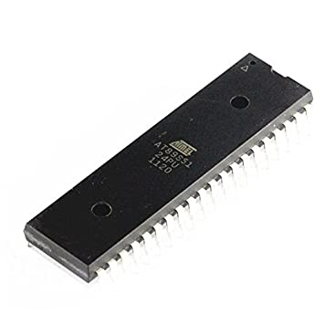

**PIN DIAGRAM:**

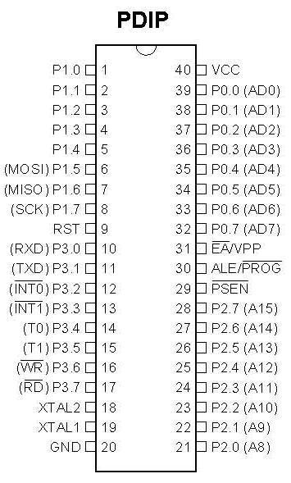

**Specifications:**

|  |  |
| --- | --- |
| **Product Attribute** | **Attribute Value** |
| **Manufacturer:** | Microchip |
| **Product Category:** | 8-bit Microcontrollers - MCU |
| **RoHS:** | [Details](https://www.mouser.in/Search/RoHSCompliant?qs=xWeWzlDFJB6CU0HrUip%2fIw%3d%3d) |
| **Series:** | [89S](https://www.mouser.in/c/semiconductors/embedded-processors-controllers/microcontrollers-mcu/8-bit-microcontrollers-mcu/?m=Microchip&series=89S) |
| **Mounting Style:** | Through Hole |
| **Package/Case:** | PDIP-40 |
| **Core:** | [8051](https://www.mouser.in/c/semiconductors/embedded-processors-controllers/microcontrollers-mcu/8-bit-microcontrollers-mcu/?core=8051) |
| **Program Memory Size:** | 4 kB |
| **Data Bus Width:** | 8 bit |
| **ADC Resolution:** | No ADC |
| **Maximum Clock Frequency:** | 24 MHz |
| **Number of I/Os:** | 32 I/O |
| **Data RAM Size:** | 128 B |
| **Supply Voltage - Min:** | 4 V |
| **Supply Voltage - Max:** | 5.5 V |
| **Minimum Operating Temperature:** | - 40 C |
| **Maximum Operating Temperature:** | + 85 C |
| **Packaging:** | Tube |
| **Brand:** | Microchip Technology / Atmel |
| **Height:** | 4.83 mm |
| **Interface Type:** | UART |
| **Length:** | 52.58 mm |
| **Number of Timers/Counters:** | 2 Timer |
| **Operating Supply Voltage:** | 4 V to 5.5 V |
| **Processor Series:** | AT89x |
| **Product:** | MCU |
| **Product Type:** | 8-bit Microcontrollers - MCU |
| **Program Memory Type:** | Flash |
| **Factory Pack Quantity:** | 10 |
| **Subcategory:** | Microcontrollers - MCU |
| **Width:** | 13.97 mm |
| **Unit Weight:** | 6 g |

**Circuit Diagram:**

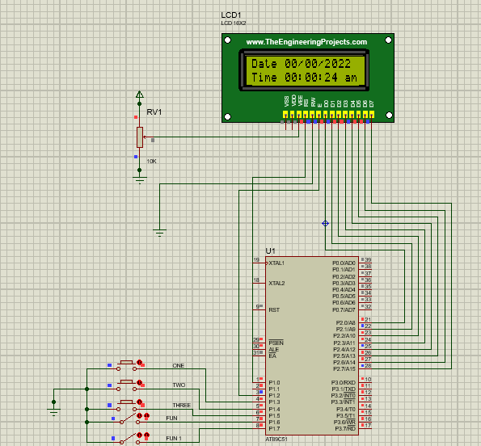

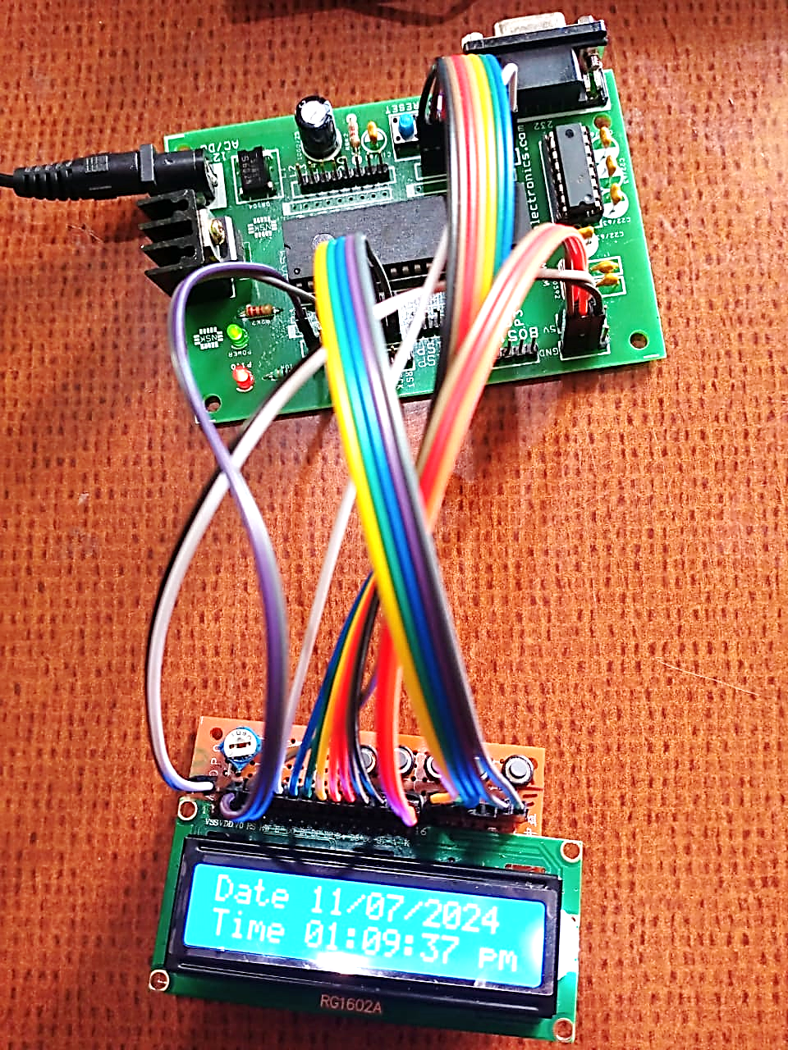

**LCD Display Module 16X2**

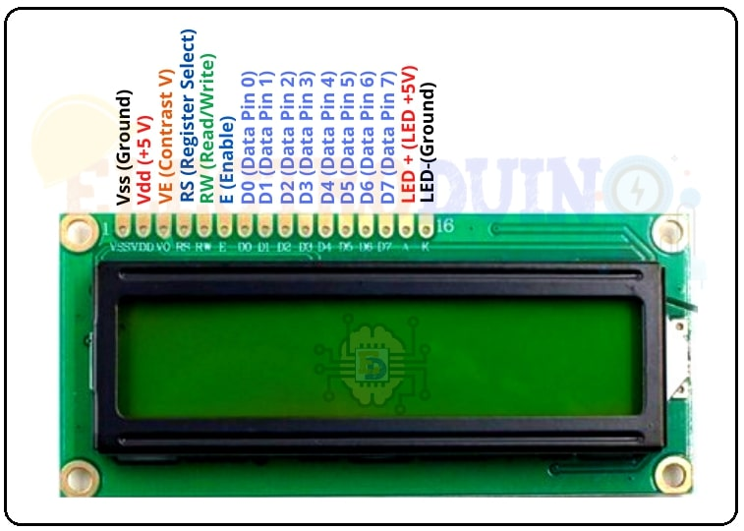

|  |  |  |
| --- | --- | --- |
|  | **Pin Name** | **Description** |
| 1 | Vss (Ground) | VSS pin connected to microcontroller ground |
| 2 | Vdd (+5 Volt) | VDD pin connected to microcontroller + 5V power supply |
| 3 | VE (Contrast V) | Adjusts the contrast of the LCD display. It is Connected to a variable POT that can provide 0-5V power supply. Connect it to the ground to get maximum contrast. |
| 4 | RS (Register Select) | Toggles between Command/Data Register. Connect a microcontroller data pin and obtains either 0 or 1(0 = data mode, and 1 = command mode). |
| 5 | RW (Read/Write) | Used to read or write data. Normally grounded to write data to LCD |
| 6 | E (Enable) | This pin should be held high to execute the Read/Write process, and it is connected to the microcontroller data pin & constantly held high. |
| 7 | D0 (Data Pin 0) | These 8 Pins are used to sending commands or data to the LCD. These pins are connected in two-wire modes like 4-wire mode and 8-wire mode. In 4-wire mode, only four pins are connected to the microcontroller data pin 0 to 3. And in 8-wire mode, 8-pins are connected to microcontroller data pin 0 to 7. |
| 8 | D1 (Data Pin 1) |
| 9 | D2 (Data Pin 2) |
| 10 | D3 (Data Pin 3) |
| 11 | D4 (Data Pin 4) |
| 12 | D5 (Data Pin 5) |
| 13 | D6 (Data Pin  6) |
| 14 | D7 (Data Pin 7) |
| 15 | LED + (+5V) | This is the positive terminal of the backlight LED of the display. It’s connected to +5V to turn on the backlight LED. |
| 16 | LED – (Ground) | This is the negative terminal of the backlight LED of the display. It’s connected to the ground to turn on the backlight LED. |

**Some LCD Commands**

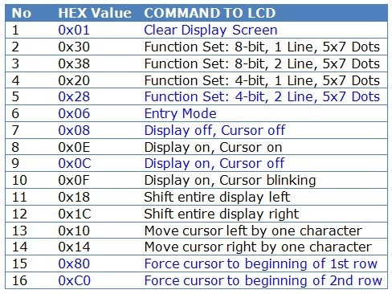

**ASCII Table**

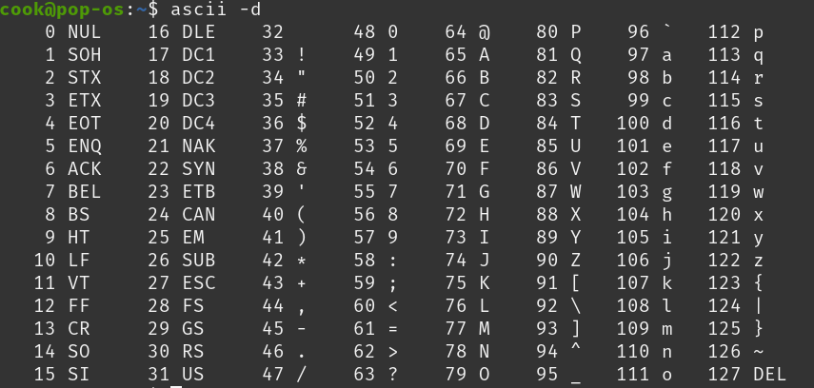

**Logic to Convert Integer to Character:**

void to_char(unsigned int value)

// FUNCTION TO CONVERT INTEGER TO ASCII VALUE

{char tens,units;

tens=value/10;

lcd_data(tens+48);

units=value%10;

lcd_data(units+48);}